
Koneru Lakshmaiah Education Foundation
(Deemed to be University estd. u/s. 3 of the UGC Act, 1956)
Off-Campus: Bachupally-Gandimaisamma Road, Bowrampet, Hyderabad, Telangana - 500 043. Phone No: 7815926816, www.klh.edu.in

STUDENT CASE STUDY EXECUTION REPORT
Department | FED
Subject | DSA-2
Academic Year | 1-111 Semester | 2025-26
Faculty Name | LAHARI
Student Name | S. VENNELA
Roll Number | 2520080018
Branch | AI&DS
Course Outcome | 4
Case Study Topic: Job Match Candidate Profile Recommendation using Dijkstra's Shortest Path Algorithm
Work Done Summary:
In this case study, we designed and implemented a Job Match Candidate Profile Recommendation System using Dijkstra's Shortest Path Algorithm. The Job Match platform was modelled as a weighted graph where recruiters and candidates are represented as nodes, and edges represent the matching cost based on skills, experience, certifications, and referrals. Dijkstra's algorithm was applied to determine the minimum-cost path from a recruiter to the most suitable candidate. This enables faster and more accurate candidate recommendations by minimizing the overall matching cost while ensuring efficient navigation through the Job Match network.
Implementation Details:
- Represented recruiters and candidates as nodes in a weighted graph.
- Assigned edge weights based on skill similarity, experience, certifications, and referral score.
- Stored the network using an adjacency list representation.
- Initialized the source recruiter node with distance 0 and all other nodes with infinity.
- Applied Dijkstra's Algorithm using a priority queue (min-heap) to find the minimum-cost path.
- Updated the shortest distance whenever a better path was found.
- Identified the candidate with the minimum recommendation cost.
- Displayed the shortest path and total matching cost.
- Compared the results with other candidate paths to verify correctness.

Result: Screenshots / Output
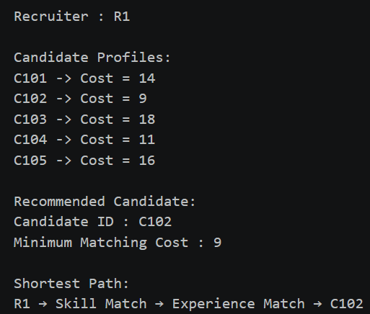
Time Complexity: -
Dijkstra's Algorithm (using Min-Heap): O((V + E) log V) .
Efficiently finds the minimum-cost recommendation path, making candidate profile matching faster and scalable.

GETHUB LINK: https://github.com/SVennela07/dsa-2-case-study

Student Signature Faculty Signature

